
IS6751 – TEXT & WEB MINING
Group Project
Sentiment Analysis Model Based on Twitter Comments

Wee Kim Wee School of Communication and Information
Semester I AY2024-2025

Submitted by:
Guo Kaihua (G2304650E)
Ren Xiao (G2405573L)
Zhao Xiajing (G2406086D)
Zhou Gaoqiang (G2304064A)

[word count: 2730]

Table of Contents
Introduction 3
Background 3
Research Objective 3
Data 4
Dataset Overview 4
Data Preprocessing 5
Dataset Review After Preprocessing 6
Methodology 7
Machine Learning Based Approach 8
Deep Learning – RNN, GRU, LSTM Approaches 9
Deep Learning – CNN Approaches 13
Pretrained Language Model – BERT Approaches 16
Conclusion & Future Improvements 17
Reference: 18

Introduction

Background
With the rapid development of social media, especially the proliferation of user-generated content on platforms such as Twitter (Zimbra et al., 2018). Compared with traditional news reports or blogs, comments on social media, as a form of real-time, language-rich, short-structured text, are more fragmented, instantaneous, and frequently updated, widely reflecting users' attitudes and emotions towards hot events, products and services. Users quickly express their personal opinions through short texts and become “sensors” of social emotions. (Ainley et al., 2021).
Sentiment Analysis, aims at identifying and extracting users' subjective emotions from natural language texts, which are usually classified into sentiment categories such as Positive, Negative, or Neutral. The breadth and openness of Twitter data provide rich resources for sentiment analysis research. Researchers and engineering practitioners can extract multi-dimensional information that can be used for a wider range of applications (Sahayak et al., 2015).
Due to the highly unstructured nature of tweet text, such as common abbreviations, spelling errors, and the use of special symbols. There may even be multilingual mixing. At the same time, the text is short and the context provides limited information, which makes traditional text classification methods more challenging when processing Twitter data (Mohammad, 2017). To solve this problem, researchers have tried to introduce deep learning methods that rely on neural networks. Such as recurrent neural networks, long short-term memory networks, gate recursive unit models. After using these methods, the accuracy of social media sentiment analysis has been significantly improved (Yue et al., 2018).

Research Objective
The goal of this project is using machine learning and deep learning techniques to build a sentiment analysis model for Twitter comments, and compare the effectiveness through multiple approaches.
- Data Preprocessing: the raw Twitter texts are cleaned, segmented and denoised to construct a sentiment analysis dataset suitable for model training.
- Multi-model comparative Experiments: based on the preprocessed dataset, the following methods are used for sentiment classification modelling:
  - Machine Learning method: Logistic Regression.
  - Deep Learning methods: RNN based (Basic RNN, LSTM, GRU), CNN.
  - Pre-trained Language Model: Bidirectional Encoder Representations from Transformers (BERT).
- Performance Evaluation and Analysis: the performance of each model on the test set is evaluated through metrics such as accuracy, recall and F1 score.

Data

Dataset Overview
This project used the Sentiment Analysis Dataset from Kaggle. It contains 1.6 million labelled Tweet content for sentiment analysis.
- Dataset Column Description
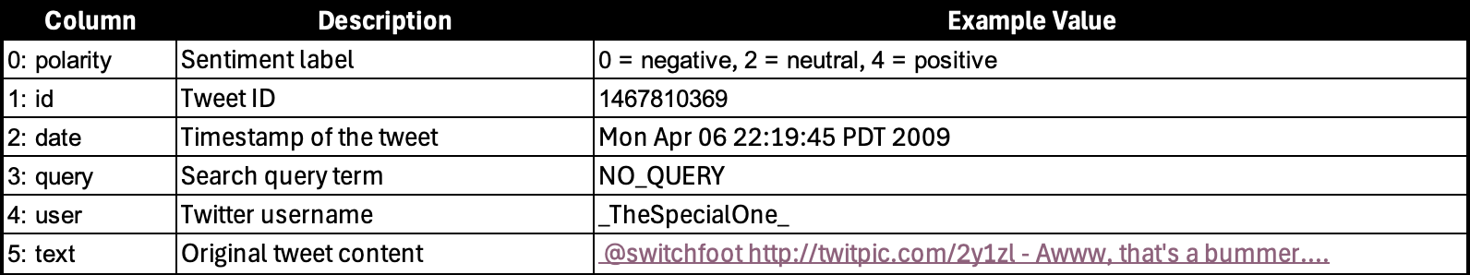
- Word Cloud
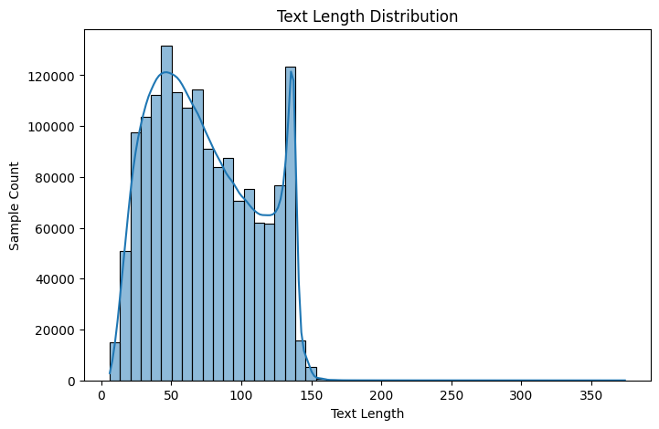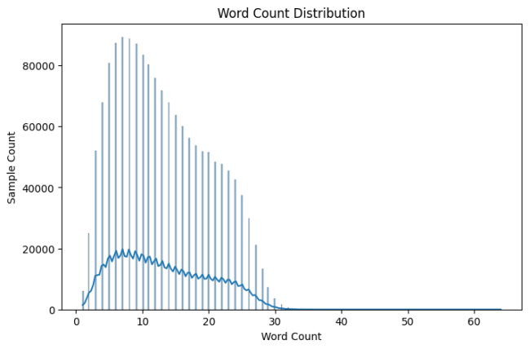
To better understand the dataset, we analyzed the distributions of text length and word count. We observed that most comments have a text length between 0-150, and the number of words is generally less than 30.
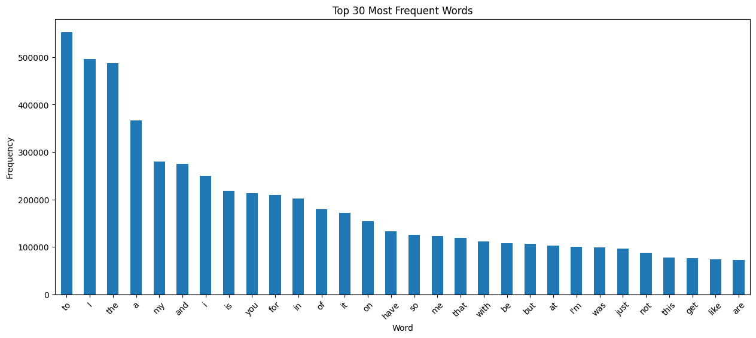
In addition, we extracted the top 30 most frequent words, but found that most of them are common stop words.
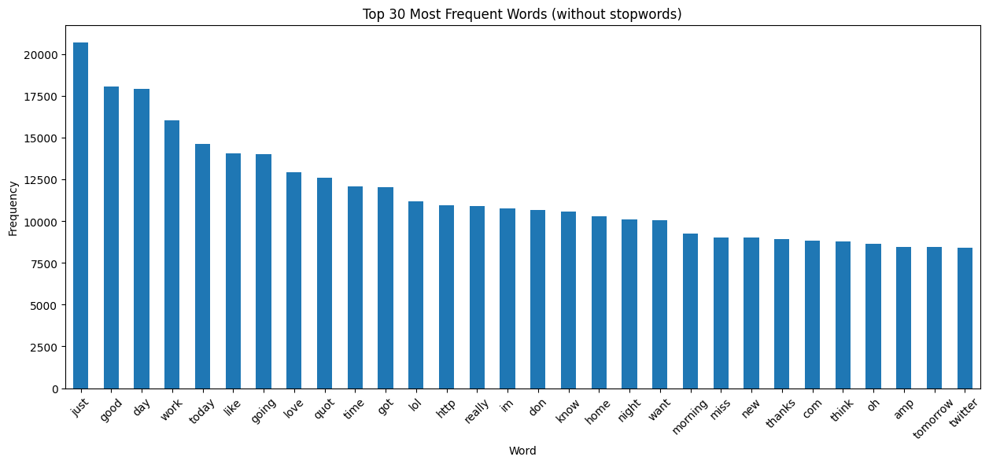
After removing stop words, the most common words are shown in the figure above.
- Class Distribution
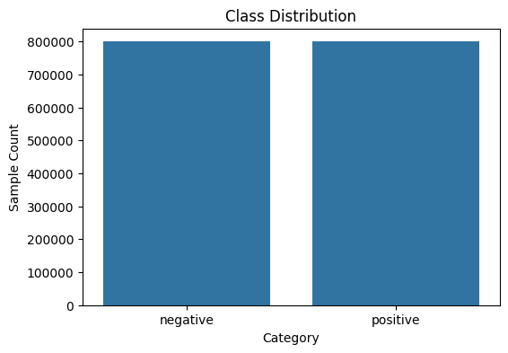
It can be observed that the dataset does not actually contain the label 2=neutral, so our classification task will not include this category. The remaining two labels, negative and positive, are perfectly balanced, indicating that the dataset is well-suited for binary sentiment classification.
- Examples
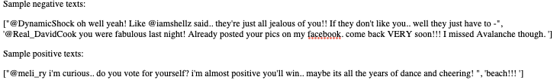

Data Preprocessing
Based on the dataset column description above, most columns are unrelated to sentiment analysis. Therefore, we retained only the “polarity” and “text” columns for our task.
To improve generalization and reduce dimensionality, additional data preprocessing approaches were applied. First, all HTML tags and brackets were removed. Next, abbreviations were expanded to their full forms. The text format like @someone and email addresses were also removed. Additionally, non-ASCII characters, including emojis and special symbols, were filtered out to maintain a clean and consistent text format for model training.

Dataset Review After Preprocessing
After completing data preprocessing, I reviewed the dataset and analyzed the proportion of infrequent words within the overall vocabulary. This was done to determine how many words to retain during training, as removing rarely used words can reduce noise, lower model complexity, and improve generalization.
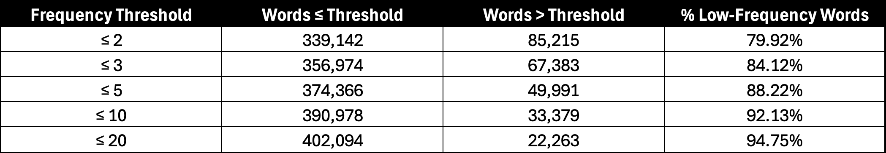
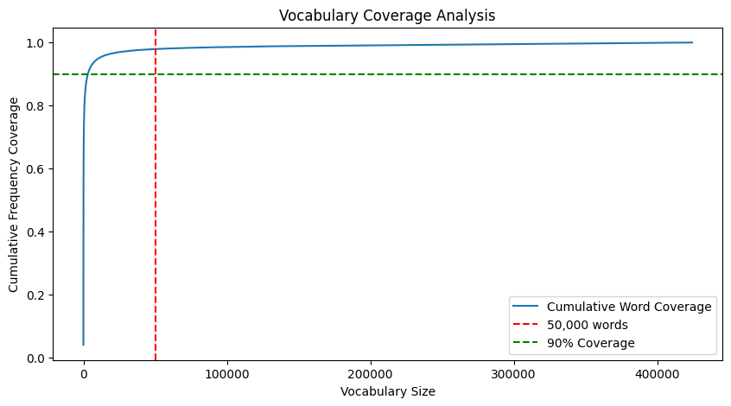
Based on the table and the chart above, if we hypothetically select the top 50,000 most frequent words, they will cover most of the text data. Each of these words appears more than five times, indicating that they are sufficiently representative and meaningful for training purposes while effectively reducing noise from low-frequency terms.

Methodology
This project built multiple different approaches to classify the sentiment of the text.
- Logistic regression (GeeksforGeeks, 2025) is a supervised machine learning algorithm used for classification tasks where the goal is to predict the probability that an instance belongs to a given class or not.
- A RNN (Graph, 2024) is a special type of ANN adapted to work for time series data or data that involves sequences. It is trained to process and convert sequential data input into a specific sequential data output. Sequential data is data such as words, sentences, time-series data where sequential components interrelate based on complex semantic and syntax rules.
- A Convolutional Neural Network (CNN), also known as ConvNet, is a specialized type of deep learning algorithm mainly designed for tasks that necessitate object recognition, including image classification, detection, and segmentation. Beyond image classification tasks, CNNs are versatile and can be applied to a range of other domains, such as natural language processing, time series analysis, and speech recognition (Sharma, 2024).
- Bidirectional Encoder Representations from Transformers (BERT), a novel pre-trained language model, which pioneered the use of a bidirectional Transformer architecture. This allowed the model to capture contextual information from both directions in a sentence simultaneously (Devlin et al. 2019). Since its release, BERT has demonstrated outstanding performance across various natural language processing tasks—including sentiment analysis, which is the focus of this project (Schomacker, T, 2021). Therefore, this paper uses BERT as a benchmark model for comparison.
The following is a flow chart of this project.
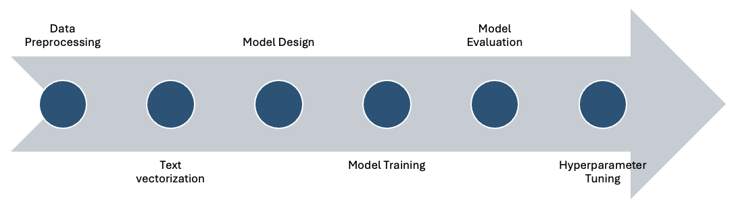

Machine Learning Based Approach
Due to the large size of the dataset, using logistic regression as initially planned resulted in high computational cost. Given the many tunable hyperparameters and optional preprocessing steps, it was challenging to efficiently explore and identify the optimal configuration.
To address this, Naive Bayes classifier is adopted first, which is computationally lightweight, to fix certain behaviours and preprocessing strategies before applying more complex models. And the baseline setup included a variety of preprocessing configurations and TF-IDF vectorization options. Specifically, we experimented with:
- Whether to remove punctuation marks.
- How to handle numeric tokens: removing them, converting them to works, or leaving them unchanged.
- Common TF-IDF parameters such as n-gram range, whether to lowercase, maximum feature size (refer to dataset review), and whether to remove stop word.
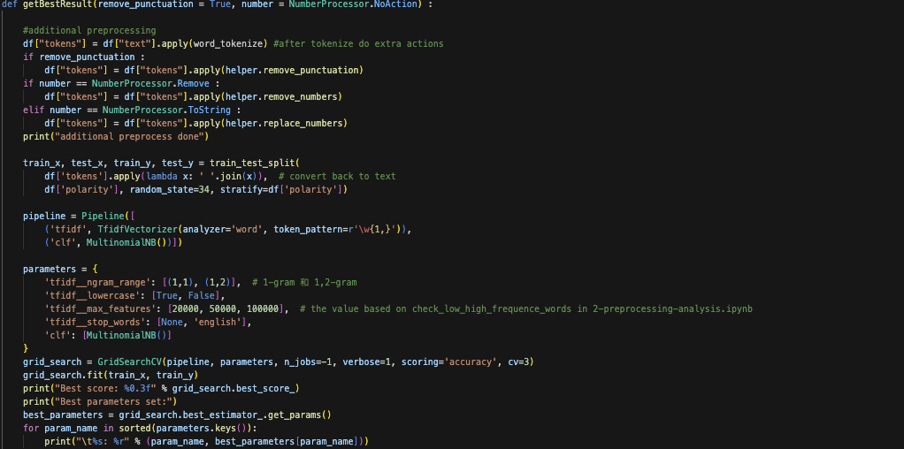
To identify the optimal configuration, we manually adjusted preprocessing strategies and conducted grid search over selected hyperparameters (refer to above code). The result performance under each combination is summarized as follows:
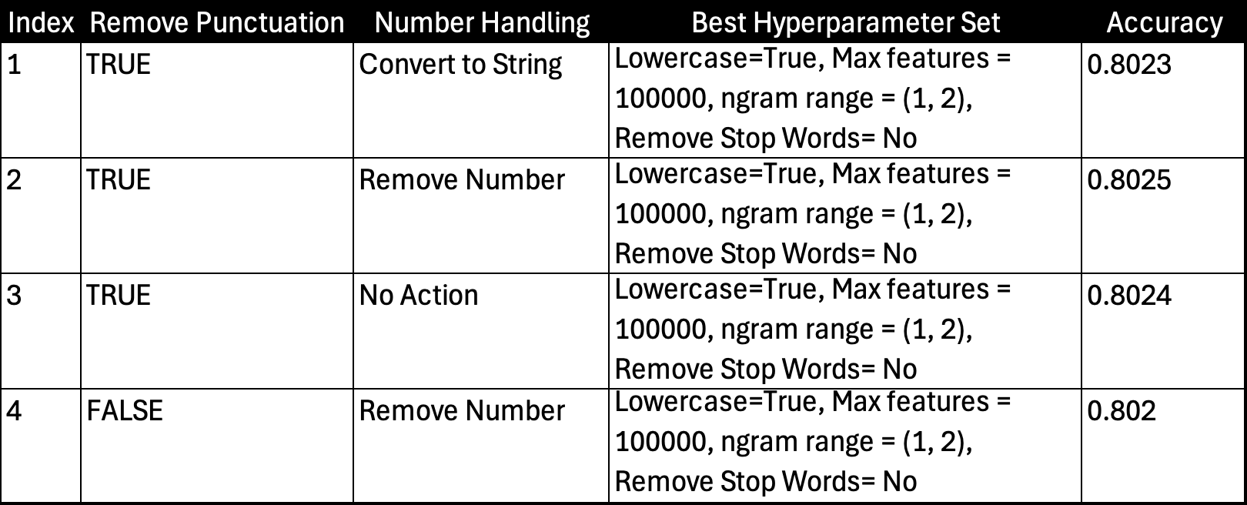
As shown above, different number handling strategies and the removal of punctuation had minimal impact on model performance. Given this observation, and to promote better generalization and reduce dimensionality, we chose to remove both numbers and punctuation in the subsequent stages. Additionally, the grid search consistently identified the same set of hyperparameters. Therefore, we adopted this hyperparameter setting and applied in directly to the upcoming experiments using logistic regression.
Then we proceeded to train the model using logistic regression, introducing an additional hyperparameter C, which controls the strength of regularization. This prevents overfitting and balances the complexity of the model. If the regularization is too weak (larger C), the model may become too complex and overfit the training data. If the regularization is too strong (smaller C), the model will be too simple and may not adequately capture the complexity of the data.
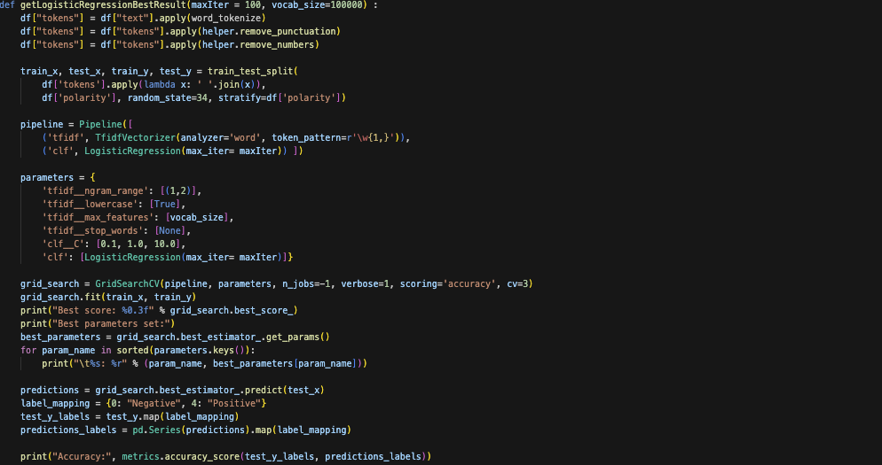
At this point, the best accuracy of the model is 0.823, and clear indicating that logistic regression outperforms Naïve Bayes in terms of classification accuracy.

Deep Learning – RNN, GRU, LSTM Approaches
Since deep learning models requires multiple epochs of training, unlike traditional machine learning, so we split dataset into a training set (70%), a validation set (15%), and a test set (15%).
Tokenize is a tool in the NLTK library that can split text data into words or tokens, so that can prepare for subsequent text analysis, feature extraction or model training. Here text data are converted into a list of words through Tokenize.
Additionally, to reduce computational load, we adopted the common machine learning practice of limiting the maximum vocabulary size (100,000) to decrease computation and improve generalization.
To enable quick and efficient classification, we designed a configurable deep learning model based on RNN/GRU/LSTM. This model offers flexible configuration options, including:
- Dimensionality of the word embedding layer (‘embed_dim’): Higher dimension settings allow for richer word semantics, but are also more computationally expensive.
- Number of hidden units in the RNN/GRU/LSTM layer (‘hidden_dim’): Controls the ability of the model to memorize sequential information. The higher the value, the more complex the pattern learned by the model, but it also increases the risk of overfitting and computation time.
- Number of stacked RNN/GRU/LSTM layers (‘num_layers’): deeper models can learn more features. However, too many layers may lead to vanishing gradients or unstable training.
- Bidirectional RNN (‘bidirectional’): Bidirectional models can process sequences forward and backward at the same time, capturing past and future context. This usually improves the performance of the NLP task, but doubles the output dimension.
- Pooling Type (‘useMax’):
  - Max (‘True’): Use maximum pooling (torrent.max) to extract the most salient features from the sequence.
  - Mean (‘False’): Uses mean pooling (torch.mean) to average information across all time steps.
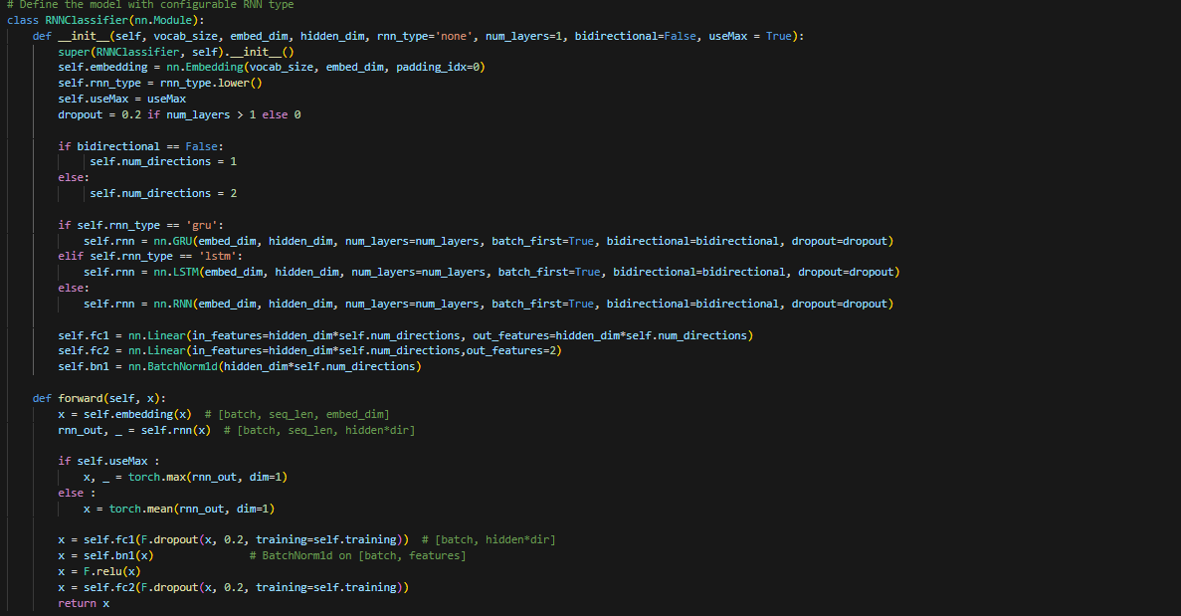
Other fixed hyperparameters:
- Dropout rate: 0.2 is usually a reasonable choice to strike a good balance between effective training and preventing overfitting.
- Number of epochs: 10 epochs is usually suitable for tasks with a moderate amount of training data and complexity. Increasing the number of epochs may result in a significant increase in training time and may even lead to overfitting.
- Batch size: A batch size of 256 is usually a compromise between using GPU resources more efficiently and not consuming as much memory as a very large batch size.
- Optimizer: AdamW is a very common and effective optimizer in deep learning, especially for neural network models with a large number of parameters.
- Optimizer Learning Rate: 0.0001 is the recommended learning rate for the AdamW optimizer, which usually leads to more balanced training results. If the learning rate is set too high, it may lead to gradient explosion during the training process; if it is too low, it may lead to slow model training or even failure to converge.
- Optimizer Weight decay: 1e-5 is usually a moderate weight decay value. Too high a weight decay value may over-penalize the weights, while too low a value may have a weak inhibiting effect on overfitting.
- Early Stop patience: Early stopping helps prevent overfitting, and patience=2 is a reasonable choice. Being able to terminate the training in time when the performance is no longer improving saves computational resources without missing the opportunity to improve performance by stopping the training too early.
Experimental:
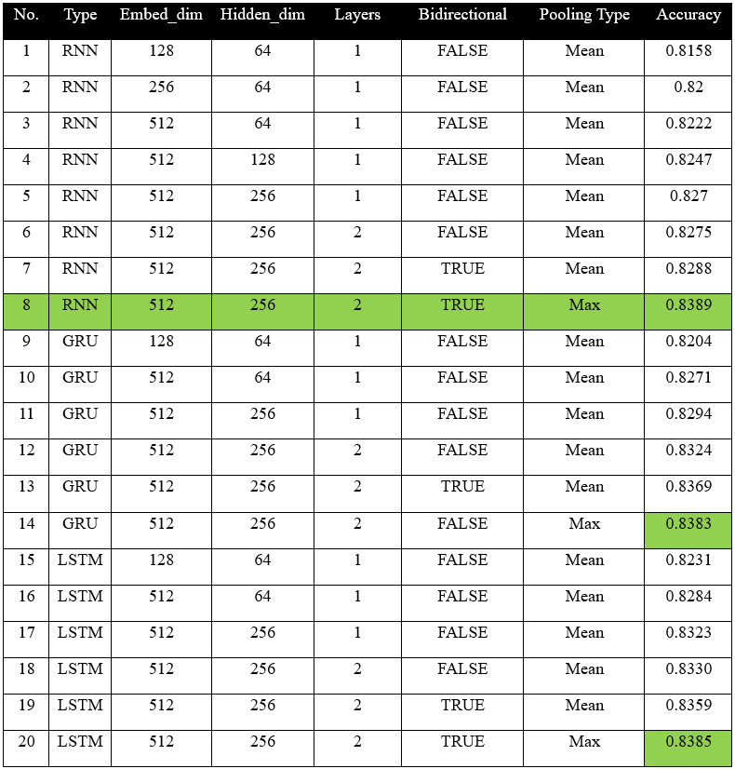
Based on the experimental result table above, the best performing configuration for RNN, GRU and LSTM models all share the same hyperparameters: embedding dimension of 512, hidden dimension of 256, and 2 layers, combined with bidirectional architecture and max pooling. Their accuracy scores are very close, which may suggest that for short texts like tweet comments, GRU and LSTM do not offer obvious advantages over a simple RNN model.
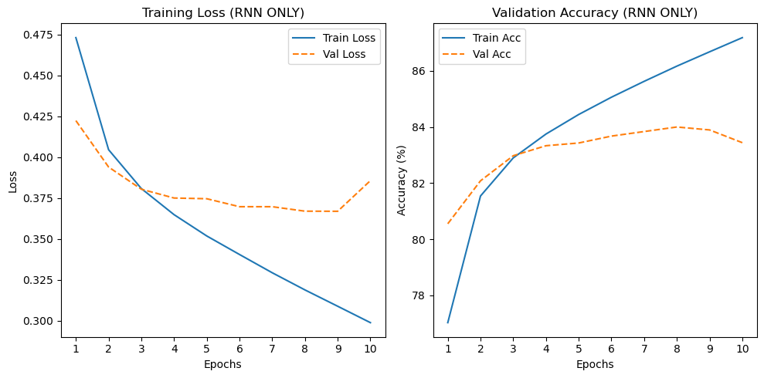
Training Loss & Accuracy (RNN - Best Hyperparameters)
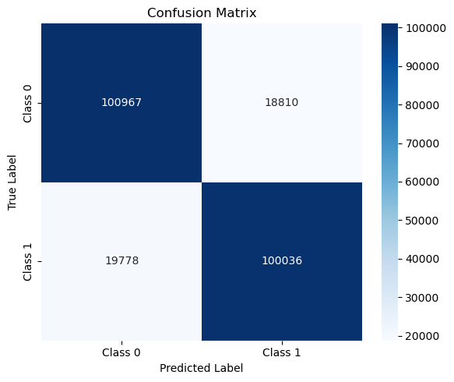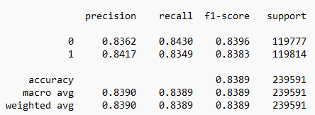
Test Confusion Matrix and Classification Report (RNN - Best Hyperparameters)

Deep Learning – CNN Approaches
Convolutional Neural Network is effective for text classification due to their ability to capture local features in sequences of words. CNNs automatically learn n-gram patterns from text and apply weight-sharing techniques to improve efficiency. In this project, different CNN models were built to explore the better performance.
As with the previous RNN approaches, we used the same training/validation/test set spilt, the same NLTK tokenizer and the same maximum vocabulary size (100000).
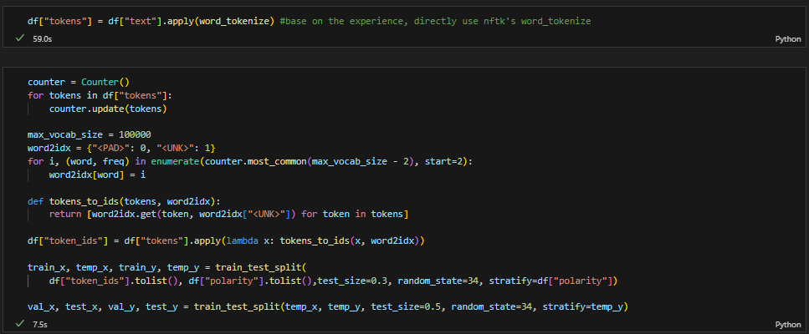
To enable efficient and flexible text classification, we also designed a configurable CNN model. This model supports several adjustable hyperparameters that influence performance and generalization. The configuration options include:
- Word embedding size (‘embed_dim’): Refers to RNN embed_dim.
- Convolutional kernel size (‘kernel_sizes’): Decides the the receptive field (i.e., n-gram size) captured by each convolutional filter. For example, kernel sizes of (3, 4, 5) enable the model to detect trigrams, 4-grams, and 5-grams. Adjusting this parameter allows the model to adapt to different types of linguistic patterns.
- Number of convolution filters (‘num_channels’): Determines how many feature channels are used per kernel size. A large number of convolution filters allows the model to learn more diverse local patterns.
- Pooling type (‘pooling_type’): Refers to RNN pooling type.
- Activation Function: Specifies the non-linear function applied after each convolution layer.
  - ReLU (‘relu’): A widely used default for non-linearity.
  - ELU (‘elu’): Helps reduce vanishing gradient issues and speeds up convergence in some cases.
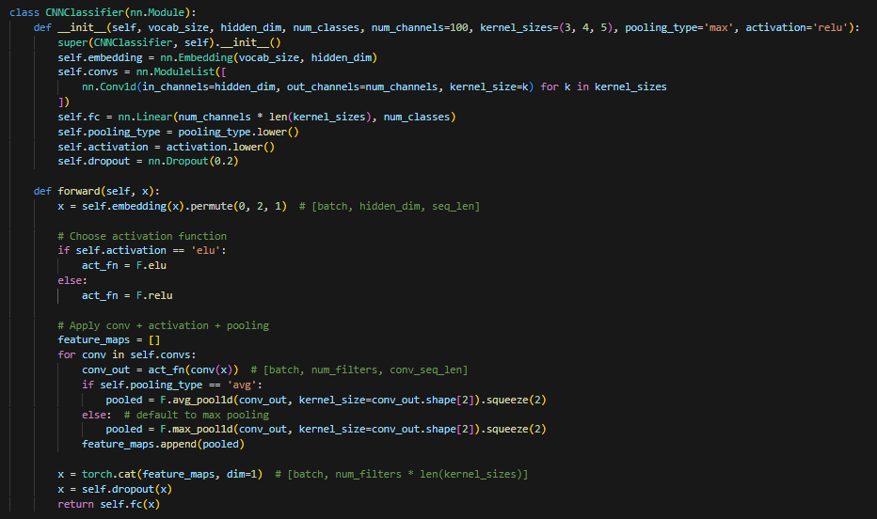
Other fixed hyperparameters: (same as RNN)
Experimental:
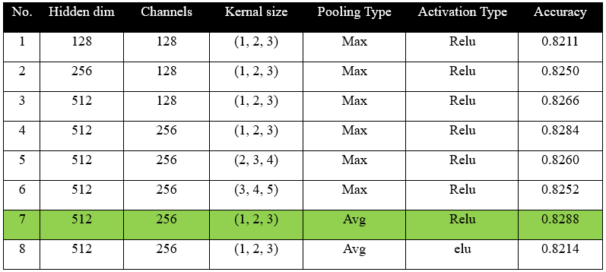
Since the pure CNN model did not perform particularly well, we experimented with combining it with RNN architectures such as LSTM and GRU to see if it could improve the results. This combination leverages the local feature extraction capability of CNN together with the temporal modeling strength of RNNs, making it potentially more suitable for emotion-related sequences. At the same time, it was necessary to introduce an additional RNN-specific hyperparameter: the hidden dimension of the RNN layer.
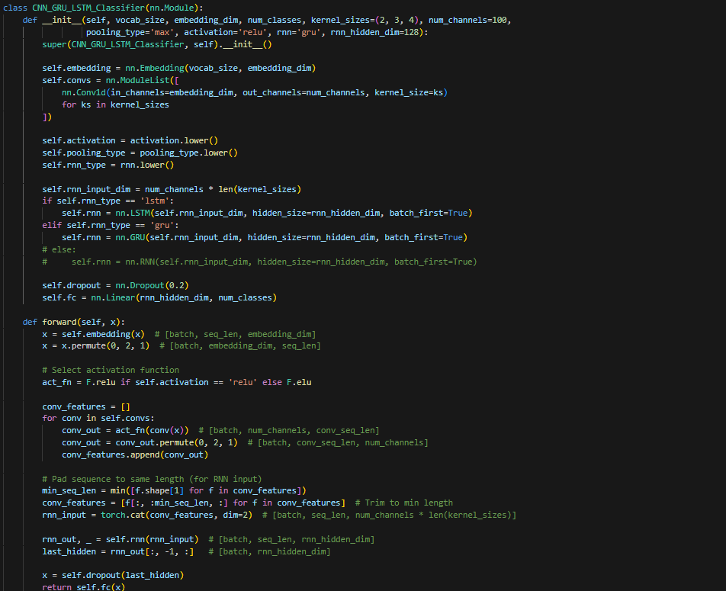
Experimental:
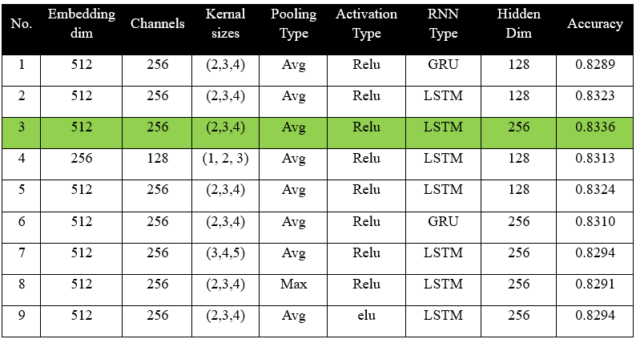
Based on the experimental results, models that combine CNN with LSTM or GRU generally outperform standalone CNNs. However, their performance still falls short compared to the plain RNN model. This suggests that in the context of emotion classification, CNN components may contribute less significantly to overall model effectiveness.

Pretrained Language Model – BERT Approaches
In the initial testing phase, we observed that due to the large size of our dataset, training the full-scale BERT model without any hyperparameter tuning would require over 50 hours for a single run. As a result, we decided to switch to DistilBERT, which applies knowledge distillation to reduce the size of BERT by 40%, and increases inference speed by 60%, while sacrificing only about 3% of its performance (Sanh et al. 2019). We collectively agreed that this trade-off is acceptable under such circumstances.
However, even with DistillBERT, training time remained considerable. To further reduce computation time, we try to limit the number of epochs to 5, and incorporated GrapScaler for mixed-precision training, which helped lower memory usage accelerate training.
In BERT training, there is a specific hyperparameter called max_length, which refers to the maximum length of the input sequence after tokenization. If the number of tokens in the original text is less than this value, the sequence will be padded; if it exceeds this value, it will be truncated.
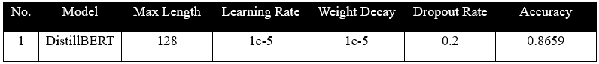
This training process took nearly 100 minutes. Although the accuracy showed significant improvement compared to other models, it became difficult to perform extensive hyperparameter tuning. Therefore, we experimented with a new model—TinyBERT. It is reported to be 7.5× smaller and 9.4× faster in inference compared to BERT, while retaining 96.8% of its performance (Jiao, X. 2020).
Based on above results, we found that switching to TinyBERT reduced the computation time by half; however, it also led to a noticeable drop in accuracy. Therefore, we decided to revert to using DistilBERT for the subsequent experiments.
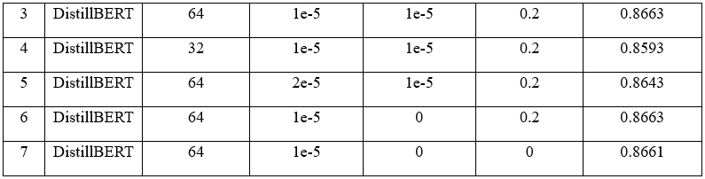
It can be observed that, apart from significantly reducing the max_length, which has a notable impact on accuracy, fine-tuning other hyperparameters does not lead to substantial performance changes. This may be because the training script is already sufficiently robust and well-configured for the task.
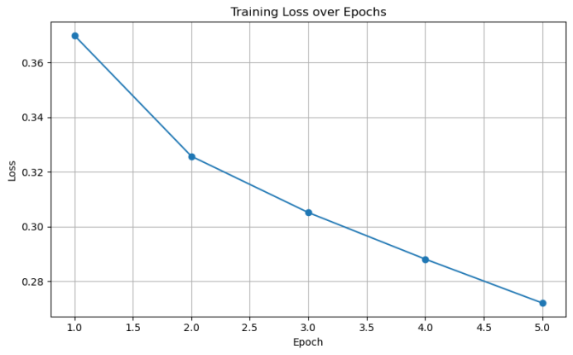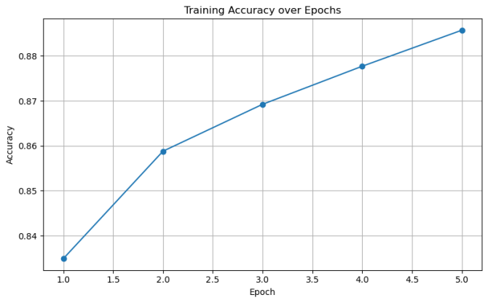
Training Loss & Accuracy
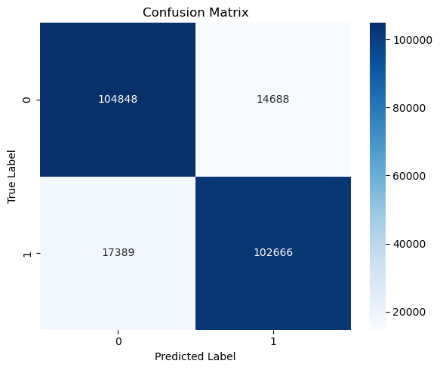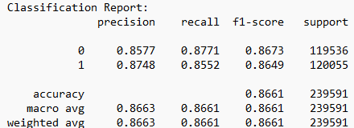
Test Confusion Matrix and Classification Report

Conclusion & Future Improvements
Best accuracy of different sentiment analysis models
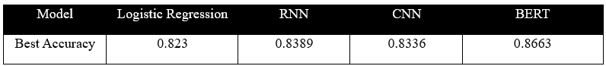
This project employed various models to perform sentiment analysis on Twitter comments. Experimental results showed that DistilBERT achieved the best performance with an accuracy of 86.63%, demonstrating the strong capability of pretrained models in classifying short social media texts. However, the training time was considerably long, highlighting the need to balance model performance and computational resources. In future work, we plan to explore more efficient models such as RoBERTa and ALBERT, leverage more powerful hardware acceleration, and apply data augmentation techniques to further enhance model robustness.

Reference:
Ainley, E., Witwicki, C., Tallett, A., & Graham, C. (2021). Using Twitter comments to understand people’s experiences of UK health care during the COVID-19 pandemic: Thematic and sentiment analysis. Journal of Medical Internet Research, 23(10), e31101. https://doi.org/10.2196/31101
Devlin, J., Chang, M.-W., Lee, K., & Toutanova, K. (2019). BERT: Pre-training of deep bidirectional transformers for language understanding. In Proceedings of the 2019 Conference of the North American Chapter of the Association for Computational Linguistics: Human Language Technologies (Vol. 1, pp. 4171–4186). Association for Computational Linguistics.
GeeksforGeeks. (2025, February 3). Logistic regression in machine learning. GeeksforGeeks. https://www.geeksforgeeks.org/understanding-logistic-regression/

Graph, R. (2024, December 7). An introduction to Recurrent Neural networks (RNNs). Medium.
https://medium.com/@researchgraph/an-introduction-to-recurrent-neural-networks-rnns-802fcfee3098

Jiao, X., Yin, Y., Shang, L., Jiang, X., Chen, X., Li, L., Wang, F., & Liu, Q. (2020). TinyBERT: Distilling BERT for natural language understanding [arXiv preprint arXiv:1909.10351]. https://arxiv.org/abs/1909.10351
Mohammad, S. M. (2017). Challenges in sentiment analysis. In Socio-affective computing (pp. 61–83). Springer. https://doi.org/10.1007/978-3-319-55394-8_4
Sahayak, V., Shete, V., & Pathan, A. (2015). Sentiment analysis on Twitter data. International Journal of Innovative Research in Advanced Engineering (IJIRAE), 2(1). https://d1wqtxts1xzle7.cloudfront.net/36584429/28.JACS10092-libre.pdf
Sanh, V., Debut, L., Chaumond, J., & Wolf, T. (2019). DistilBERT, a distilled version of BERT: Smaller, faster, cheaper and lighter [arXiv preprint arXiv:1910.01108]. https://arxiv.org/abs/1910.01108
Sharma, P. (2024, November 19). Introduction to convolutional neural networks in deep learning. Analytics Vidhya. https://www.analyticsvidhya.com/blog/2022/03/basic-introduction-to-convolutional-neural-network-in-deep-learning/
Schomacker, T., & Tropmann-Frick, M. (2021). Language representation models: An overview. Entropy, 23(11), 1422. https://doi.org/10.3390/e23111422
Yue, L., Chen, W., Li, X., Zuo, W., & Yin, M. (2018). A survey of sentiment analysis in social media. Knowledge and Information Systems, 60(2), 617–663. https://doi.org/10.1007/s10115-018-1236-4
Zimbra, D., Abbasi, A., Zeng, D., & Chen, H. (2018). The state-of-the-art in Twitter sentiment analysis. ACM Transactions on Management Information Systems (TMIS), 9(2), 1–29. https://doi.org/10.1145/3185045

